**CENWP-OD-B 31 July 2023**

**MEMORANDUM FOR THE RECORD**

**SUBJECT: 23BON071 MFR AFF Valve 15 Pacific Lamprey and Juvenile Chinook Mortalities**

On the morning of 31 July, Columbia River Inter-Tribal Fish Commission (CRITFC) Biologists notified Bonneville Project Biologists of five Pacific Lamprey mortalities and two adult Chinook salmon found on the Valve 15 trash rack in the Adult Fish Facility (AFF). The fish were scanned for PIT tags, inspected, and returned to the river.

#1

1. 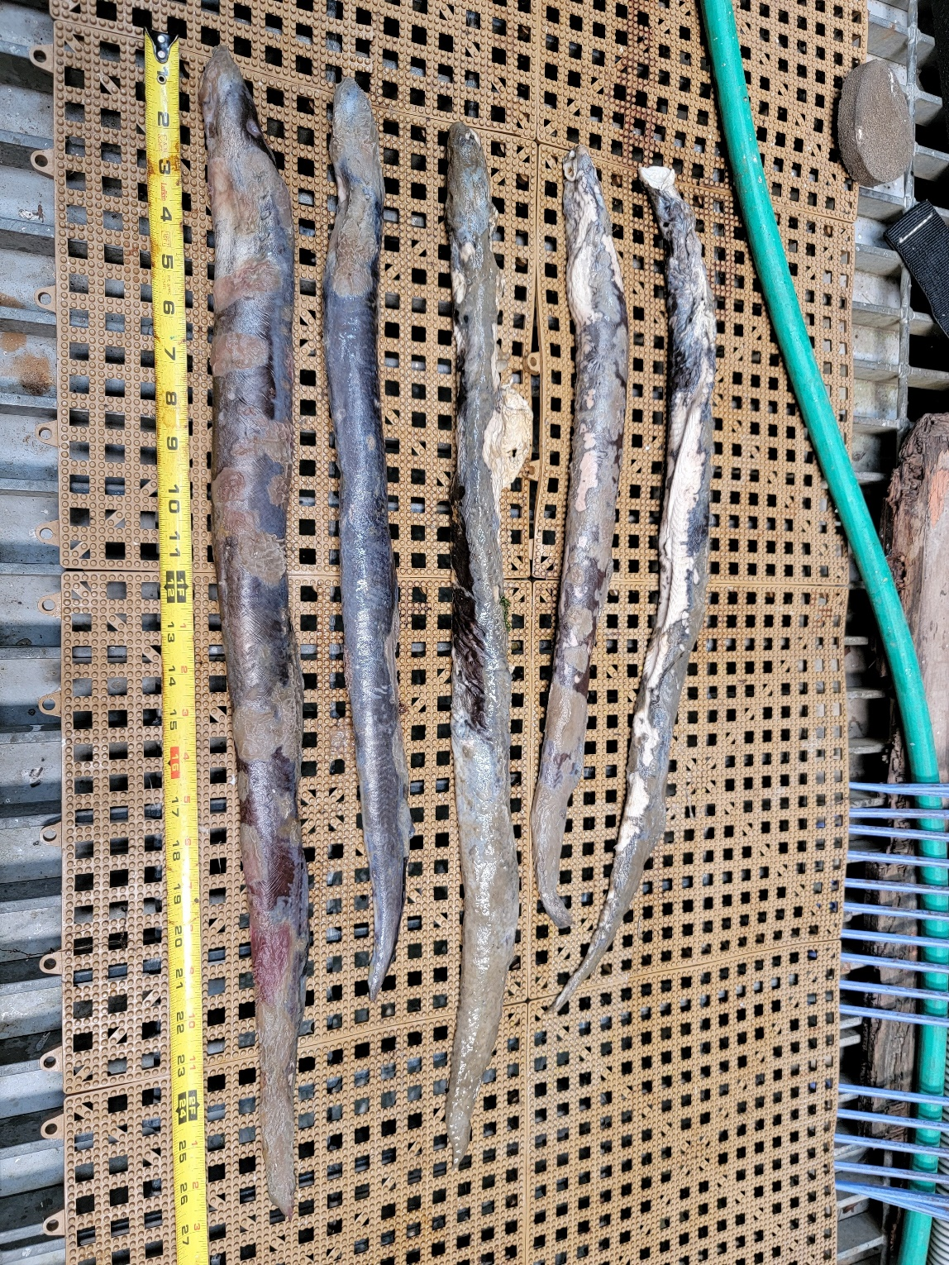Species – Pacific Lamprey (*Entosphenus tridentatus)*
2. Origin – Unknown
3. Length – In descending order: 63.5 cm, 55.9 cm, 69.2 cm, 57.4 cm, 69.9 cm
4. Marks and tags – None
5. Marks and Injuries found on carcass – General decay
6. Cause and Time of Death – Unknown
7. Future and Preventative Measures – None

#2

1. Species – Chinook Salmon (*Oncorhynchus tshawytscha)*
2. Origin – Unknown
3. Length – In descending order: 22.9 cm, 23.6 cm
4. Marks and tags – Adipose fin clips, no PIT tags
5. Marks and Injuries found on carcass – General decay
6. Cause and Time of Death – Unknown
7. Future and Preventative Measures – None  
     
   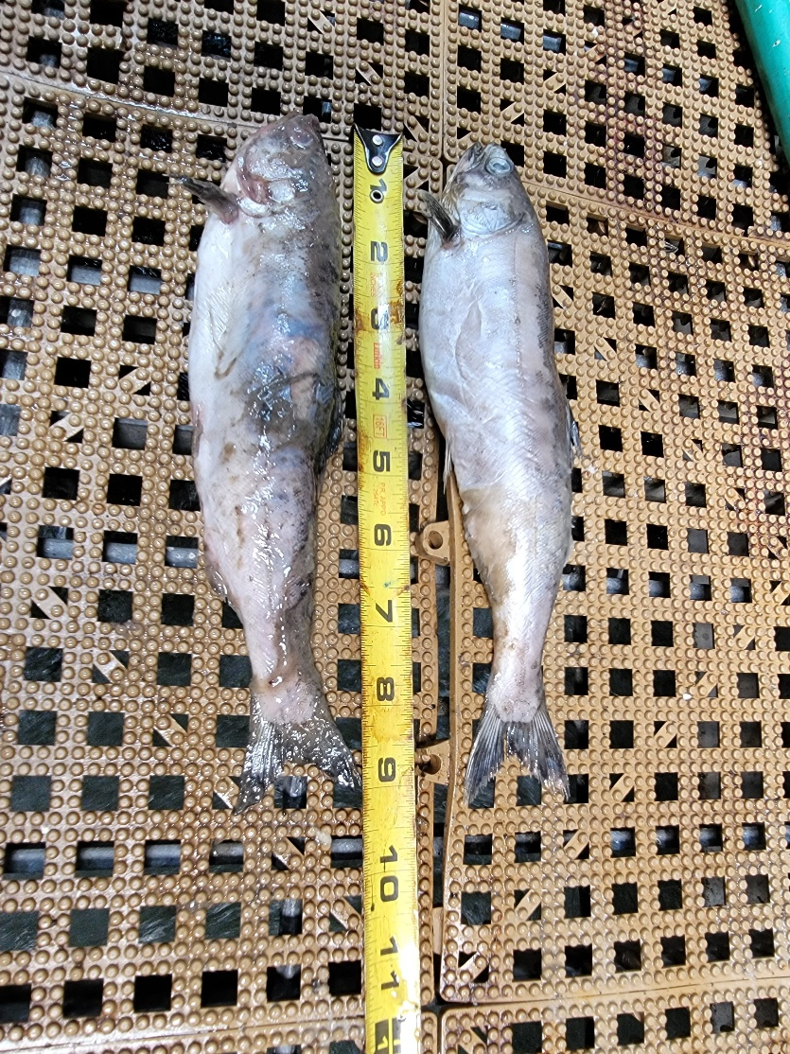

Sincerely,

Project Fisheries